NatureScope
- Dataset
We have two options for dataset
- Insect dataset only which contains 4700 species nearly not possible or required extra deep research to find good images of 4700 classes
- All animal species (animals, birds, mammals, insects) dataset possible because it is easier to divide species and to find images
- Client have sent dataset
- While analyzing the dataset there are multiple images of birds and plants but the requirement is insects’ detection
- It means the 4700 species in that dataset are not all insects so we have to find which is insect and which is not
- Cleaning the dataset requires much time because we need to separate insects from background (some insects colour blend with background in dataset)
NOTE: Dataset Collection Is Time Consuming Process
Problem
- Dataset is too large 4700 species mean I need at least 200-500 images per class/specie pr that dataset contains 2-3 images in most of the classes so I have to find 100 images per class for now
Suggestions
- I will try it on colab using smaller dataset of at least 500 species if that works, I will increase the dataset time to time
Problem
- Upon downloading the dataset from INaturalist it is not giving me images it is only giving me excel files which are not enough for deep learning
Suggestions
- So, I am using jupyter to download images directly from site
- For now, I am only using 1000 insect’s species per class 100 images

- Model Training
Problem
- As I said earlier, I need a GPU to train that model for instance I have 4700 species and each specie contains 100 images which will become 4,70,000 images which is large enough and also will take time to train on colab or Kaggle.
- I am giving you this as a borderline because most of the species do not have 100 images they contain less than that.
- If it is not just used for England then we need to find more species
Problem
- Most of the classes contains less than 100 images.
Suggestions
There are three options
- Download separate dataset of that specific specie (Best if datasets are available) from this site https://www.gbif.org/
- Download images of that specie from google (Time consuming)
- Augmentation (Good but maybe accuracy will not be that good)

- Model Deployment
Plan
- After Training the trained model size must also keep in consideration because according to my best of knowledge the trained model will be ~100mb but it is a guess maybe the trained model will be less in size
- The RK3566’s NPU speaks RKNN format. The flow is: PyTorch → ONNX → RKNN (INT8).
Problem
- Rk3566 has some limits like we are doing real time detection then it will make rise some problems e.g. lagging, so it is better to se RK3576 or RK3588
Suggestions
- A tiny fast model (YOLO11-n or YOLO11-s detect) looks at the camera frame and draws a box around anything that looks like an insect/animal.
- a few boxes like will be built around the object
- Now we crop the picture inside each box and pass only that small crop to a second model (YOLO11-s-cls).
- This model says the species name (e.g., “Small White Butterfly”).
- detector finds, classifier names.
- But still, it’s just a suggestion we will further see what will be its negative impacts

Chip | CPU (plain words) | NPU (AI accel) | Vision models (INT8) | LLM/text (on-device) | Best for | Not ideal for
RK3566 | Basic cores (good efficiency) | ~1 TOPS | Good – real-time with small nets (MobileNet/YOLO-nano) | OK only with tiny models (≈1–3B @ int4) and short answers | Cost-down device, fast species ID, short AMA | Big LLMs, AR/graphics-heavy UX
RK3576 | Mid-range (big+small cores) | ~6 TOPS | Very good – more headroom, higher input sizes | Noticeably faster than 3566; small LLMs feel smoother | “Sweet spot”: better AMA speed, future AR, richer UI | Ultra-low-cost or ultra-low-power builds
RK3588 | High-end (fast big cores) | ~6 TOPS | Excellent – complex pipelines, multi-camera ok | Best of the three; can handle a bit larger model | Max performance, AR/graphics, heavy multitasking | Tight budget or small battery devices

NOTE: without Testing we are not sure which processor is best or better for these tasks
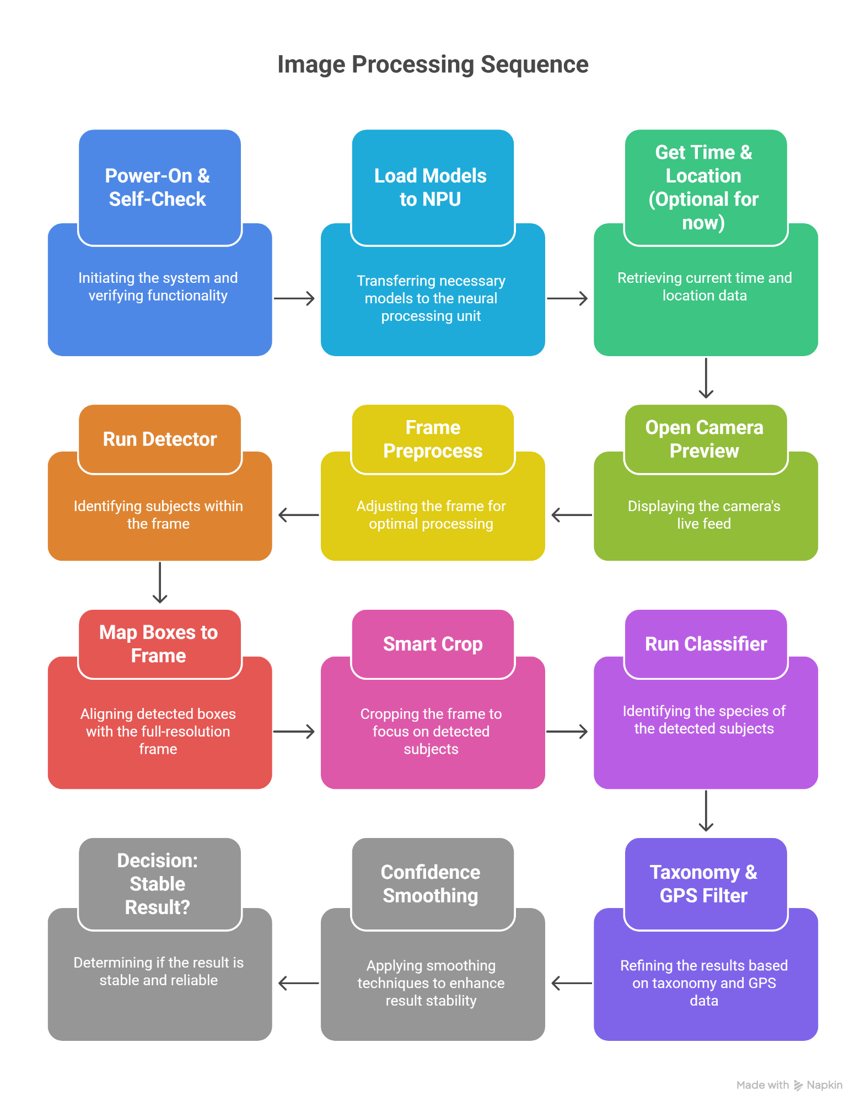

NOTE: THIS FLOW-CHART IS NOT COMPLETE THIS IS JUST INITIAL STEPS MORE BLOCKS WILL BE ADDED IN FUTURE ACCORDING TO NEED

